PROJECT TITLE: E-Barangay

PROJECT TEAM –

Kamila Lagman – Project Leader  
Jhonel Deluna - Project Developer  
Daren Mar Cabral – Project Developer  
David Warren Arcellana – Project Developer  
Ansel Christian Sevilla – Project Developer

TABLE OF CONTENTS

PROJECT OVERVIEW –

The Barangay Project is a Web-based application that can store, receive, accept and process data of the user. These features fit perfectly to help citizens of the Philippines to easily experience the services being offered by the government and making use of the technology to their own advantage. With “helping Filipinos” in mind, developers were asked to create a system that helps the lowest form of the government which is the barangay. Every barangay in the Philippines provides services to their constituents. But with the Barangay Project, it bring “providing of services” to a whole new level. Government services that the barangay provides will be available online. From requesting an ID, clearance, business permit, submitting documents, to postings of current news, events and happenings in the barangay. And of course the system’s security will always be a top priority. That is why registration and approval are a critical part of the systems features and a requirement in order for users to actually use the system.

INTRODUCTION – Make a story, current problem, benefits

In one paragraph, briefly cite the situation your proposed project prototype is targeted to be used, why and for what purpose. Briefly explain the significance or importance of this project to the target users/beneficiaries (and the society as a whole).

PROBLEM STATEMENT – The problem in most barangay is that they are using old system that uses pen and paper, the problem with this is the data that gathered is not secured much because there are some instances that the data might lose or destroyed by calamities or accidents.

Also, some of the barangay citizens are not knowledgeable about the requirements in documents like barangay id, barangay clearance, Cedula, business permit and any other barangay documents, or they didn’t know about what’s happening in their community like events, news, happening or gatherings to attend.

In one to two paragraphs, state that who or what, where, when, how & why does the problem exist. Identify the different stakeholders that are affected in the problem situation. Write this in a cause-&-effect analysis perhaps include the involvement of different stakeholders/users in the situation to point out your recommendation towards the proposed solution, i.e. project concept.

PROPOSED SOLUTION / Benefits of the System – E-Barangay ease the life of barangay citizens in by getting the barangay documents like barangay id, barangay clearance, Cedula, business permit and any other barangay documents in one system because they don’t need to go directly in the barangay to get these documents also, it includes news, happenings and information about the barangay therefore citizens are always updated about these information. The user target of the system are the barangay officials like barangay chairman down to lowest positions and it covers different departments like health and information also the barangay citizens

The system is designed and programmed in web-based application and also it has a responsive design for smart phone use. It requires internet connection for real time processing…

Explain in one to two paragraphs why is the proposed solution designed and programmed that way, e.g. easy access, target users, application portability, pervasive usage of mobile and internet, etc., highlighting its low-cost, e.g. affordable data servers, cloud computing services as data centers, or stand-alone WLAN, etc., yet efficient in its functionality, e.g. data-handling, storage, filtering, etc.

SYSTEM REQUIREMENT ANALYSIS –

|  |  |  |  |  |
| --- | --- | --- | --- | --- |
| User Type | Role Description | Information Needs | Source of Data | Function on Data |
| Citizen | Request Documents  (e.g barangay id, barangay clearance, Cedula, business permit, etc.) | Information in registration | Citizen information | Acquire documents after requesting |
| Barangay Official | Verifying request | Requested documents of citizens | - Citizens account | Officials get information of the citizen about their requested document |
| Superuser | Root | Data of all users | Barangay Official and Citizen | Control the system |

Explain the different user information requirements according to their classification &/or category, what information do they need to function or operate, when do they need it (e.g. hourly, daily, weekly, monthly), who/how/where is this information retrieved, updated & stored. Best way to present this is in a tabular (tables) format with properly labeling at the top, e.g. user type, role (or task) description, information needs, source of data, function on data, frequency, etc.

FUNCTIONAL SYSTEM SPECIFICATIONS –

|  |  |  |
| --- | --- | --- |
| User | Module | Process |
|  |  |  |
|  |  |  |

Using a tabular format, list down all modules with a logical ID numbering system & define what does this module do, who are th e users of this module, what process (function or operation) does the user &/or the application program (or subsystems) will do.

You may use SCREEN SHOTS here with PROPER LABELING & captions per screen page to visualize the intent and purposes of the program module or subsystem.

USER ACCEPTANCE TESTING –

* Request Documents

With the identified users & information requirements, provide a checklist &/or a list of routines that each user will do to check on the prototype for testing whether it meets their needs or not, &/or its ease of use that is not that different from their present manual operation.

SYSTEM DESIGN -   
Show the different diagrams as listed below with proper captions/labels/description.

USE CASE TOOL ANALYSIS

CONTEXT LEVEL DIAGRAM  
 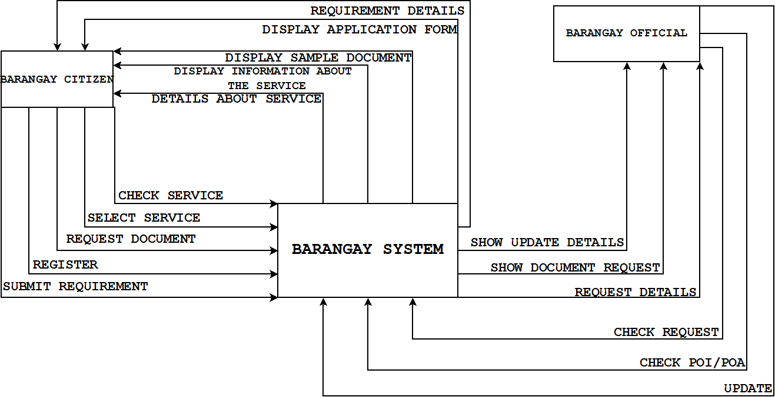  
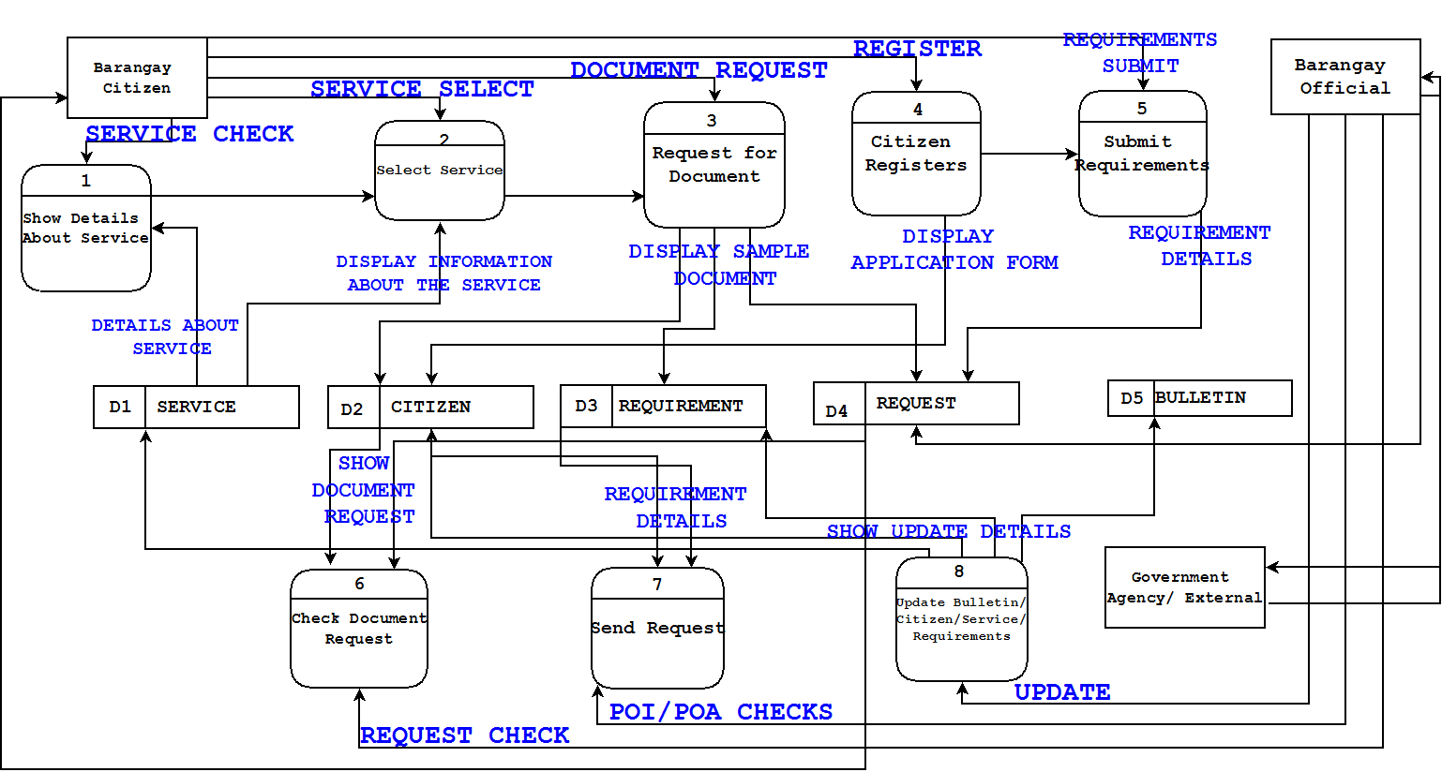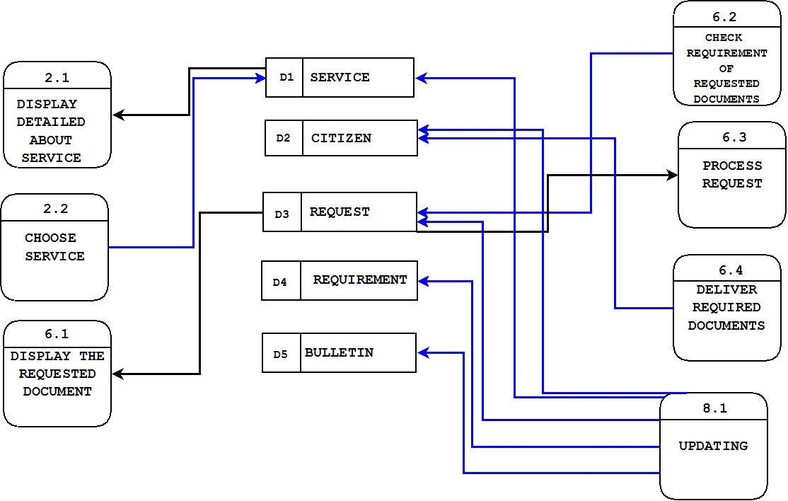

DATA FLOW DIAGRAM

SCREEN SHOTS PER MODULE

ENTITY RELATIONSHIP DIAGRAM

DATA TABLES

DATA DICTIONARY

NETWORK DIAGRAMs

SYSTEM CONFIGURATION –

Operating System: Windows, MacOS, Linux  
Programming Language: PHP, Javascript, JQuery  
Software development toolkits: XAMPP  
Framework: Cobalt  
Drivers: Network Driver, LAN, WLAN  
Installers:  
Hardware:  
Servers: Software-based  
  
List down the operating system, programming language(s) or software development toolkits, drivers, installers as well the hardware, i.e. servers, data centers or cloud computing necessary for the proposed system prototype to be scaled up for production run.

CONCLUSION

* The system ease the life of the citizen by requesting documents online
* It assure data security of the system

Highlight in bullet form how your proposed system fulfilled in resolving the issues &/or causes to the problems raised earlier & how much of a benefit will this serve to the target users (which could include the identified stakeholder(s) earlier mentioned)